**Using MatPlotLib :**

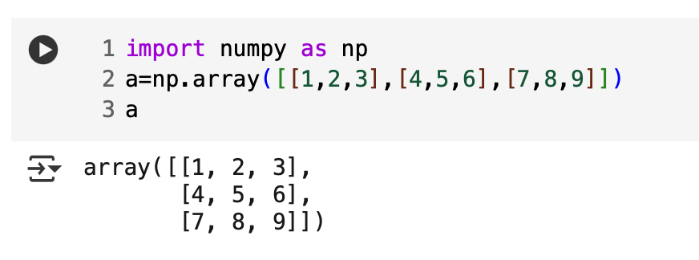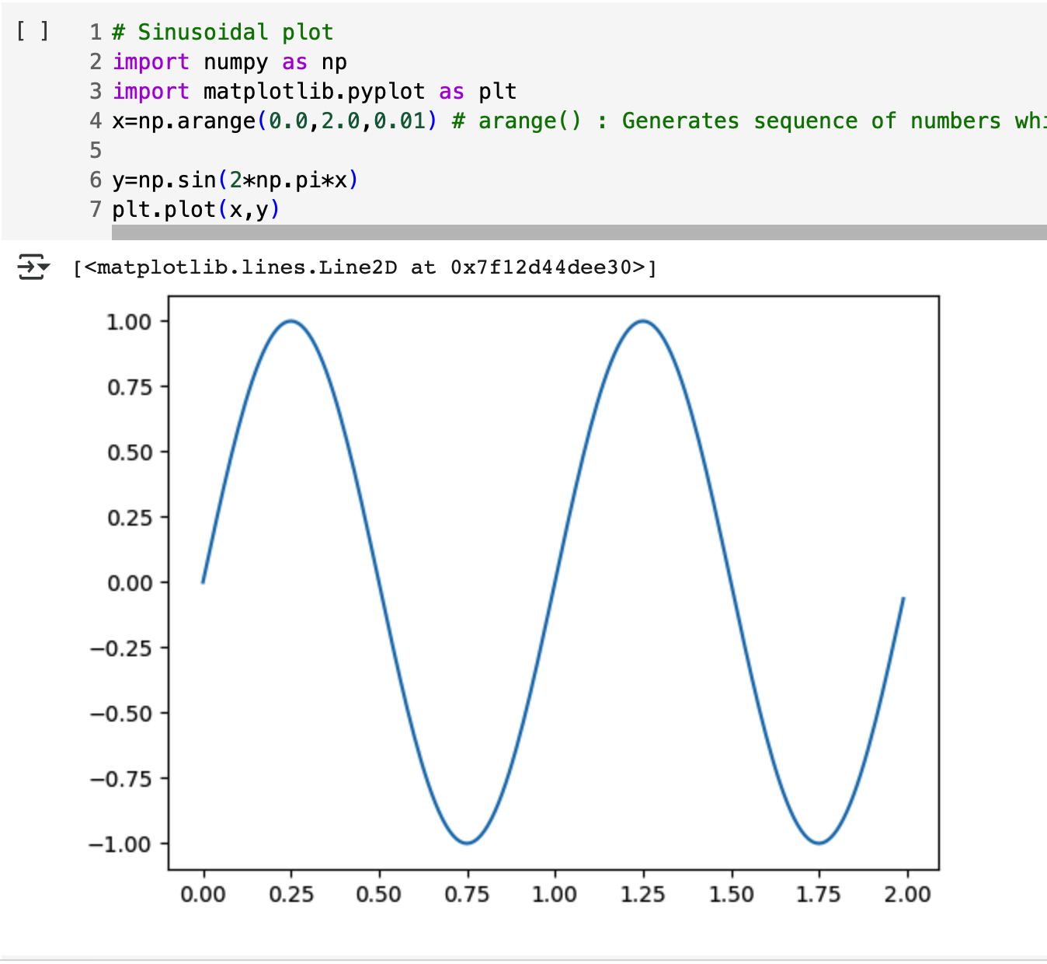

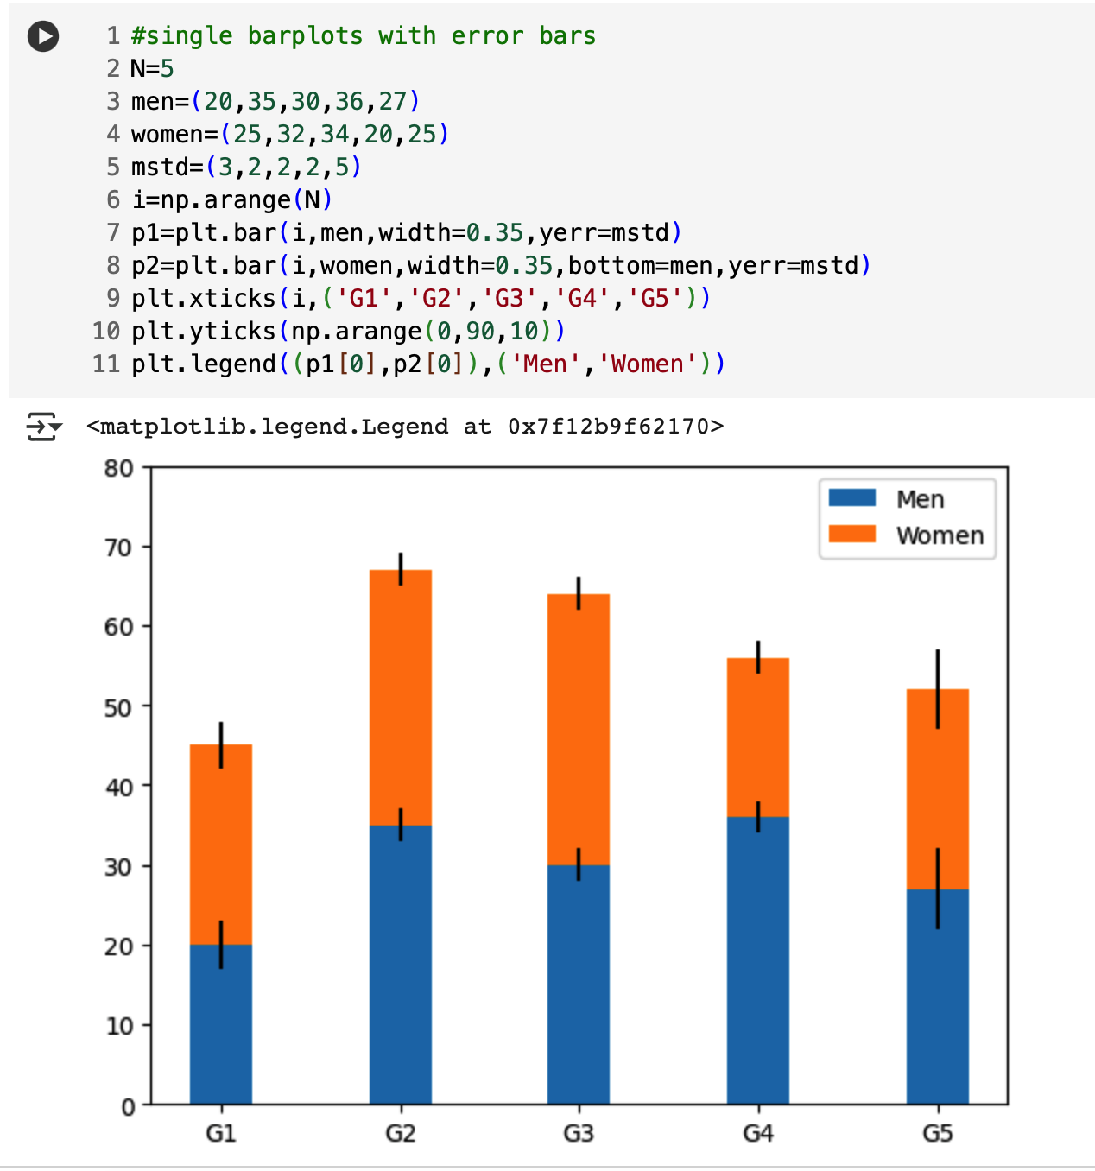

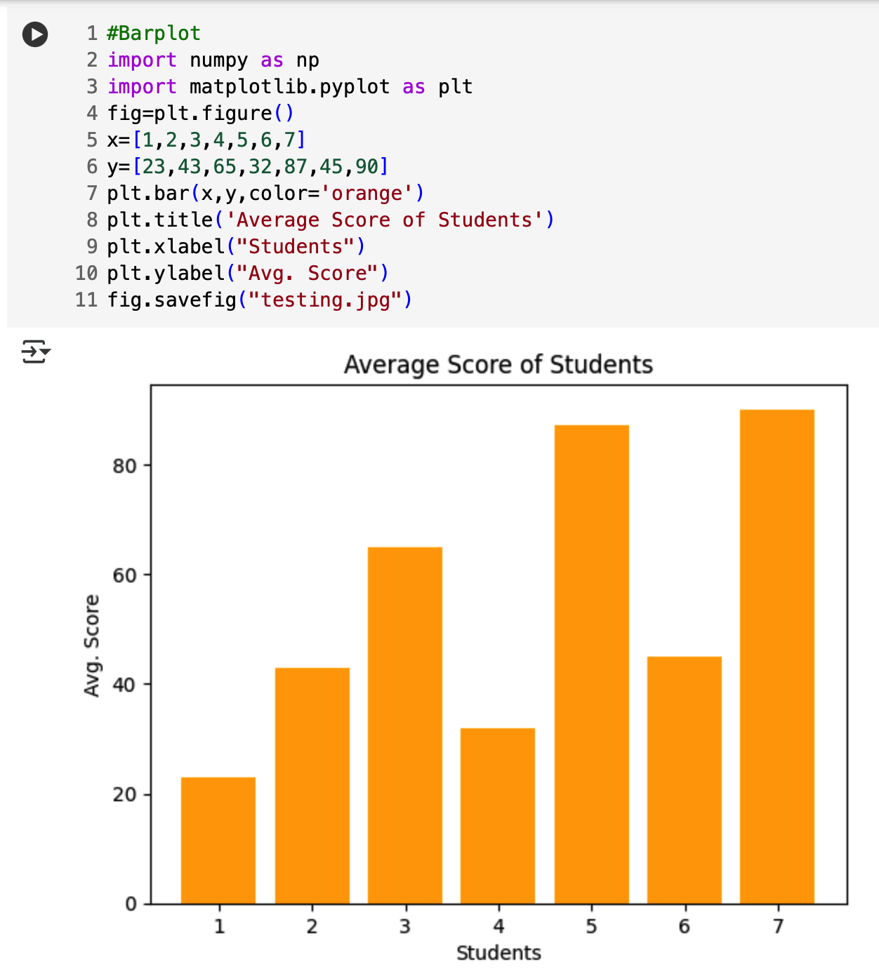

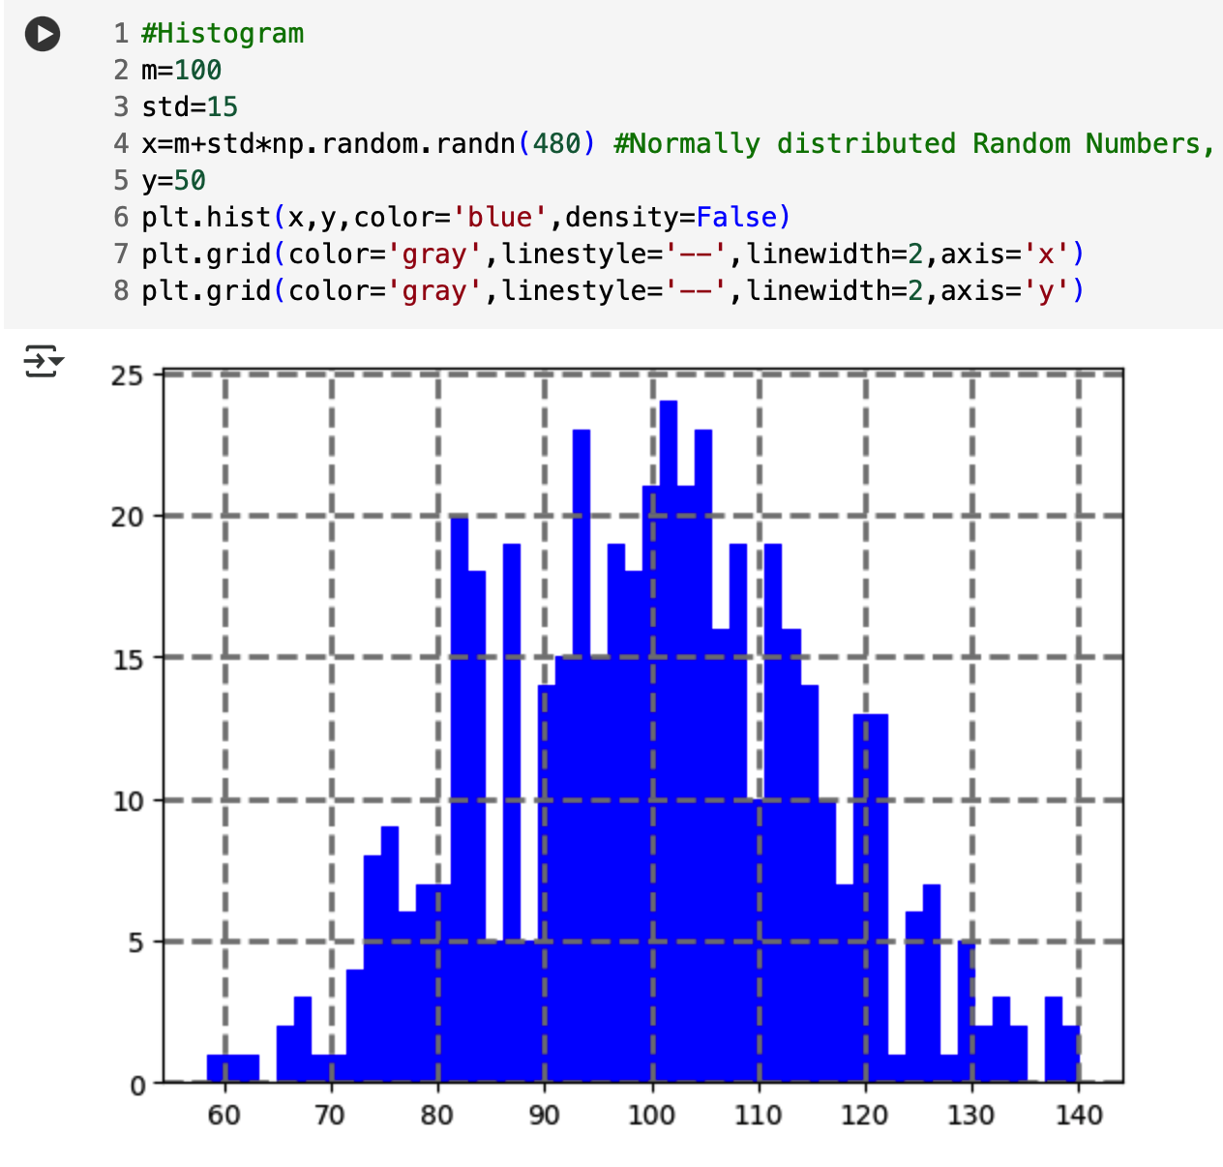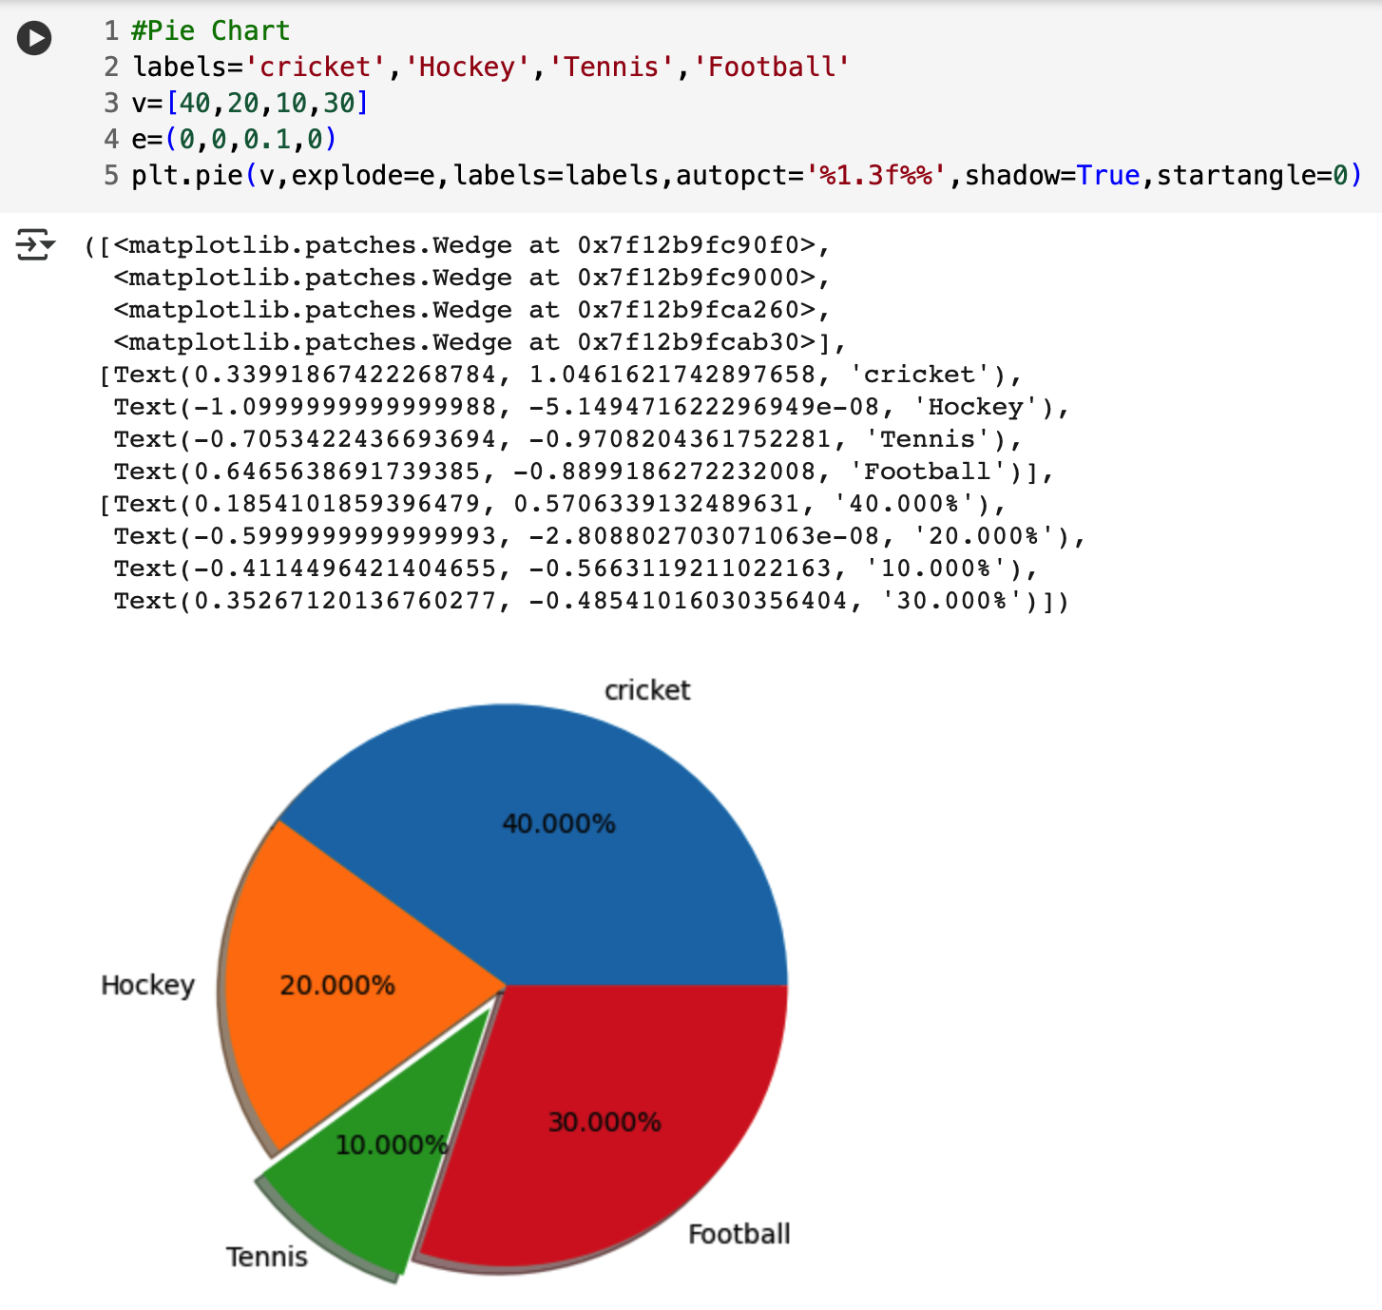

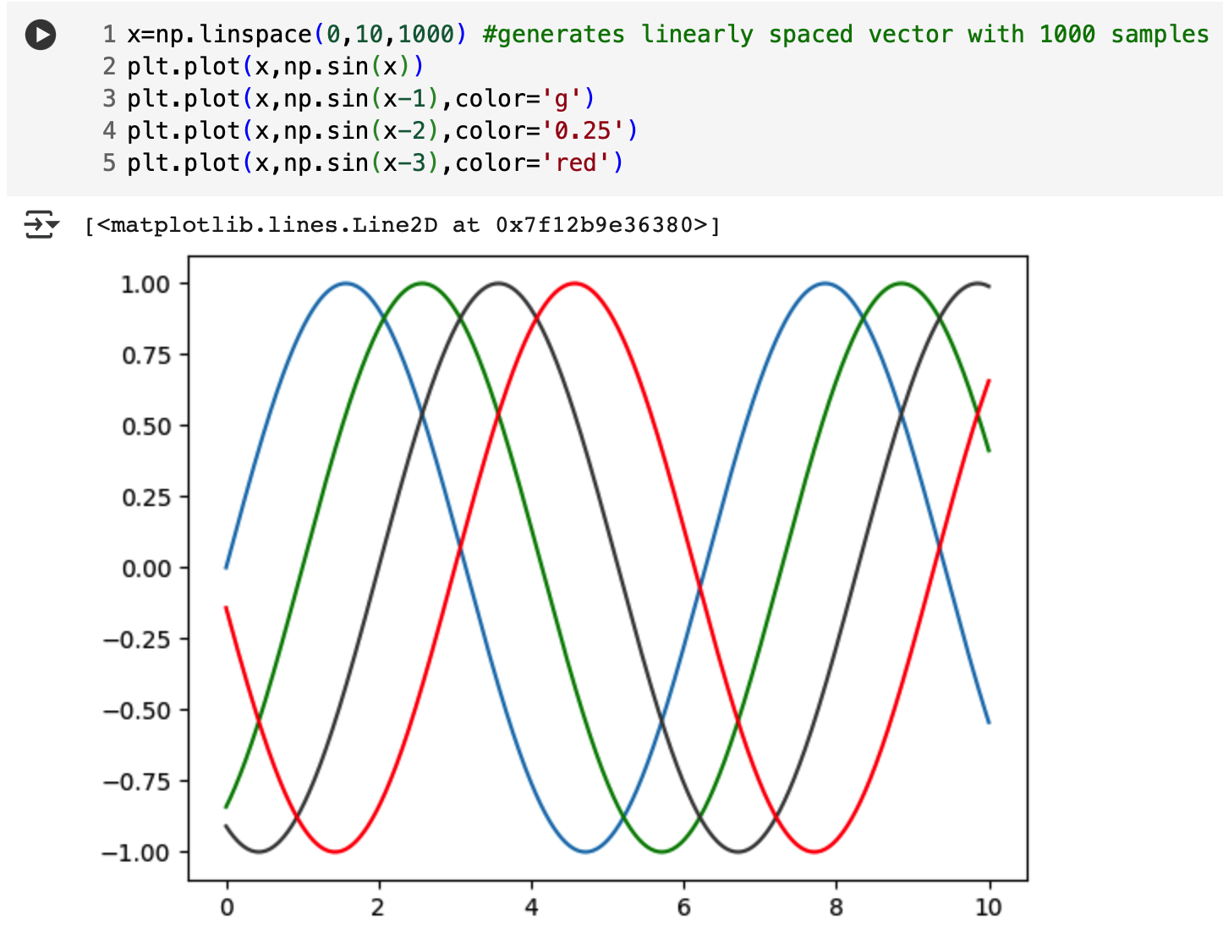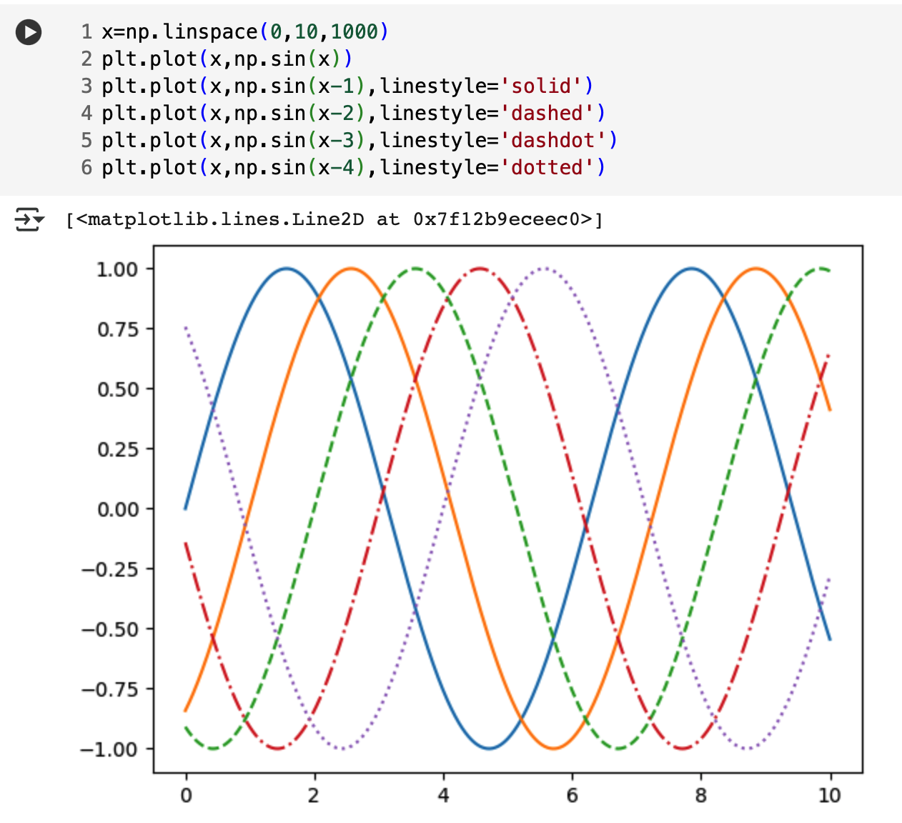

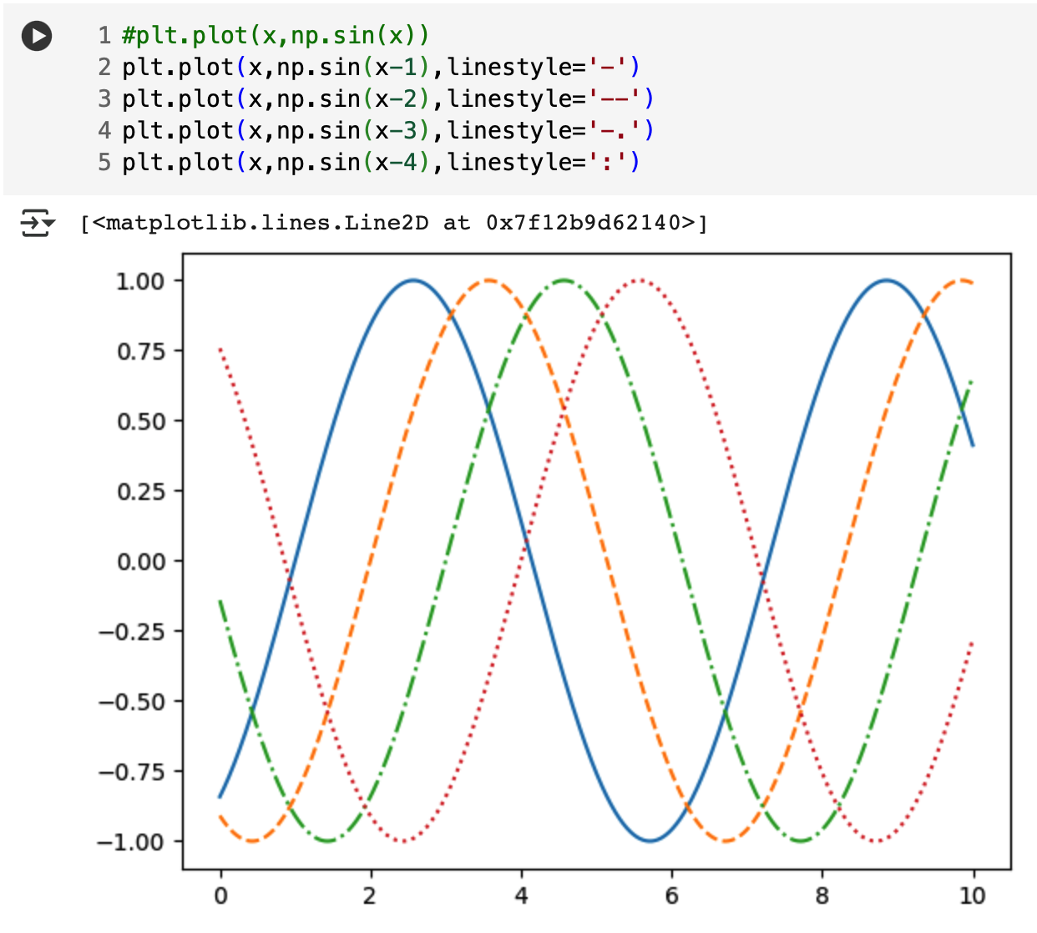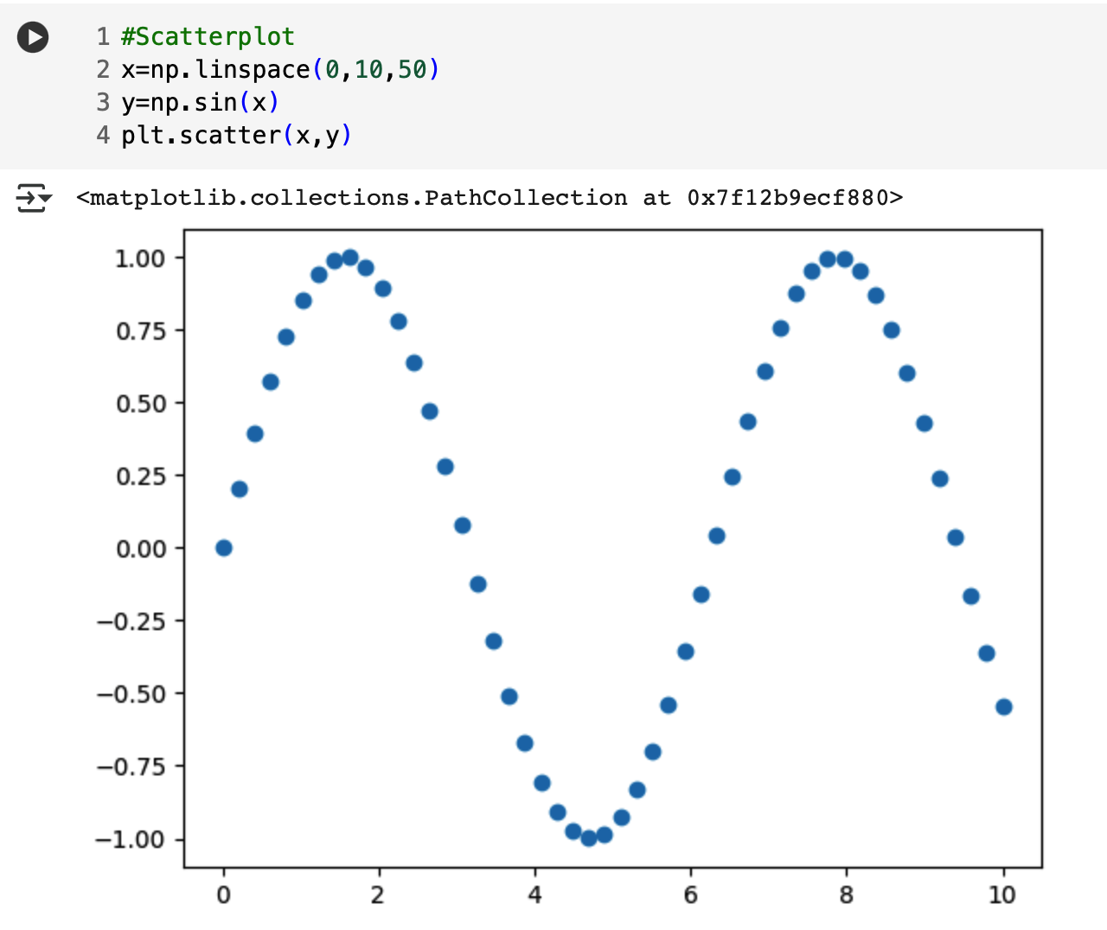

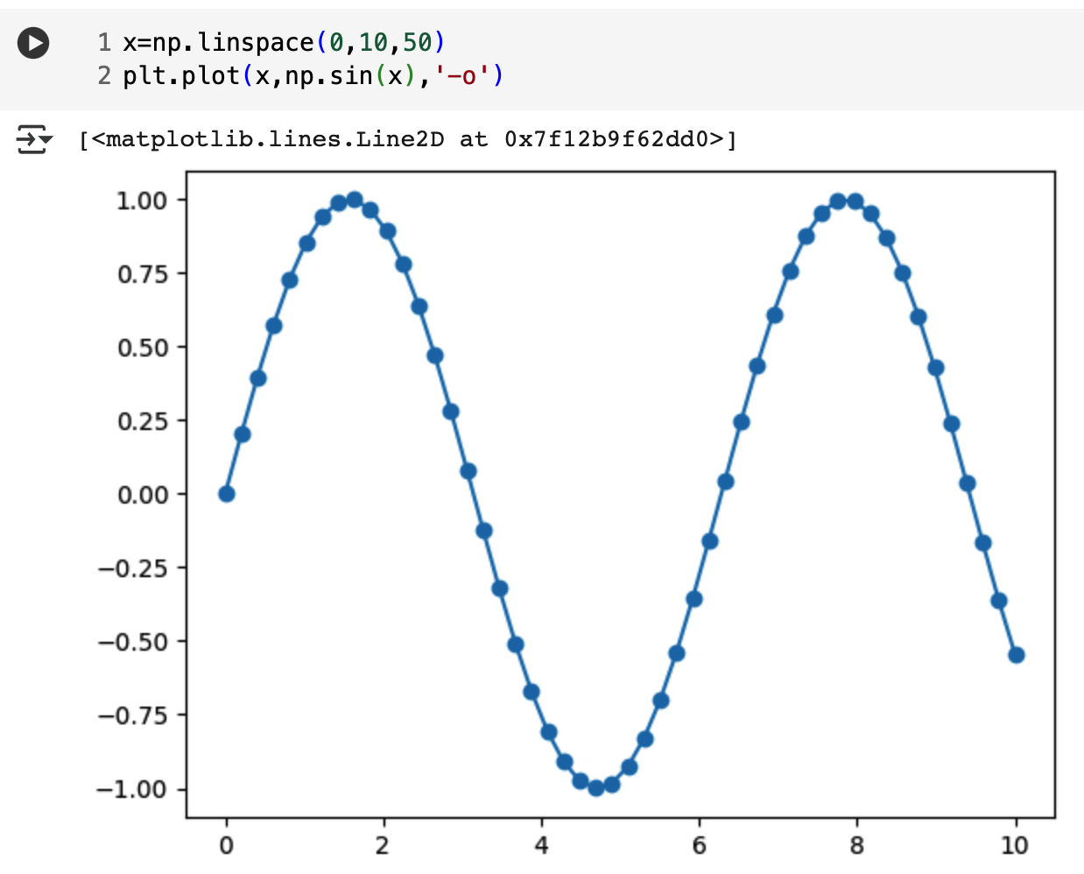

**Using Seaborn :**

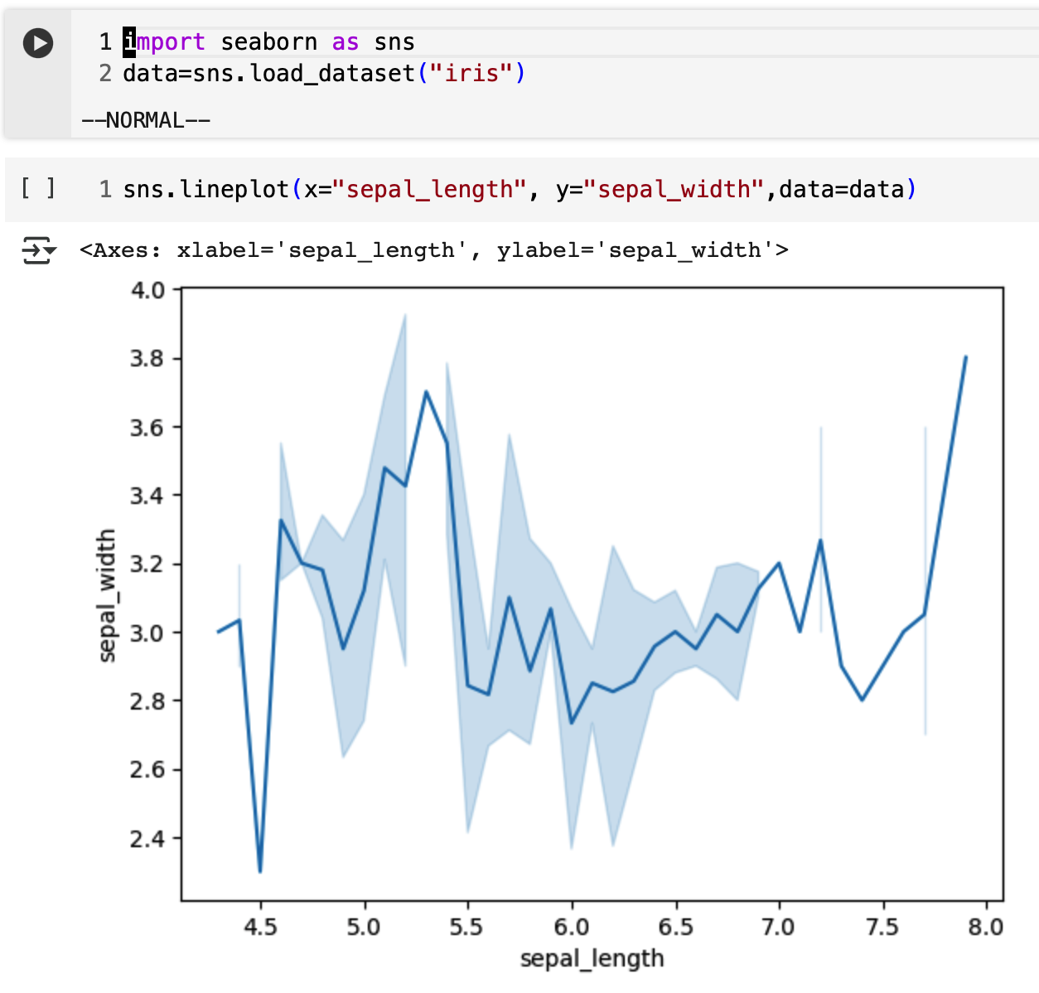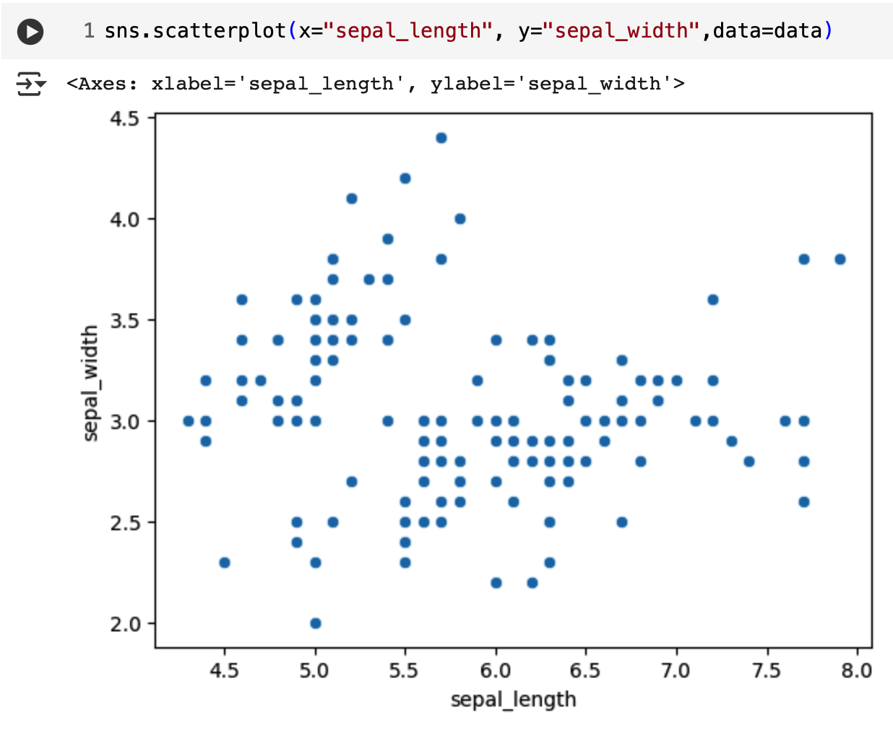

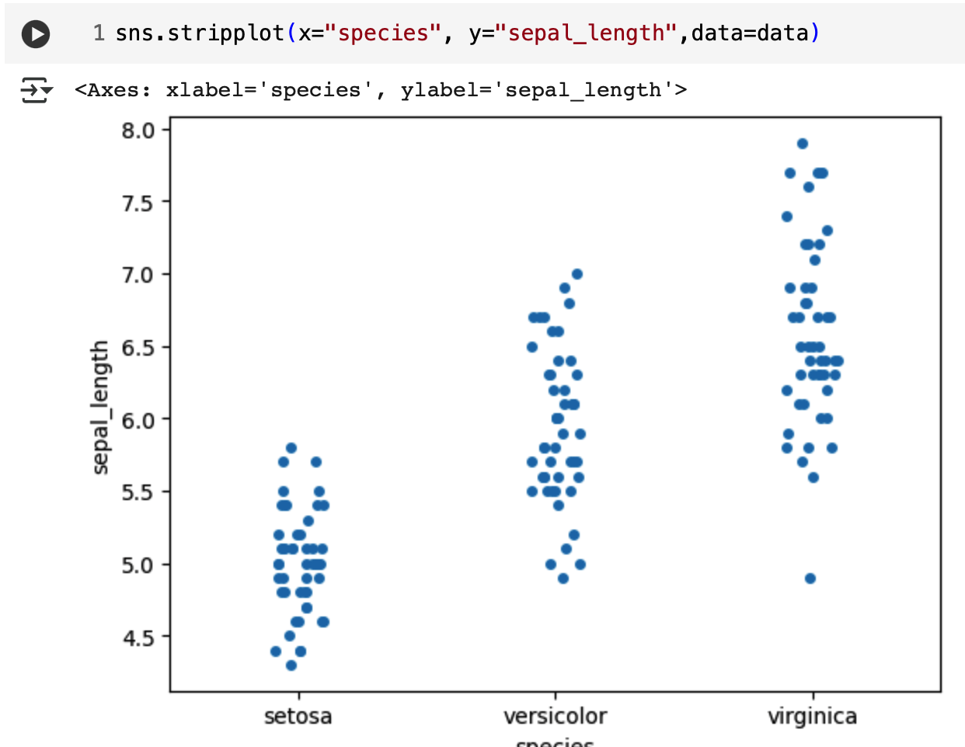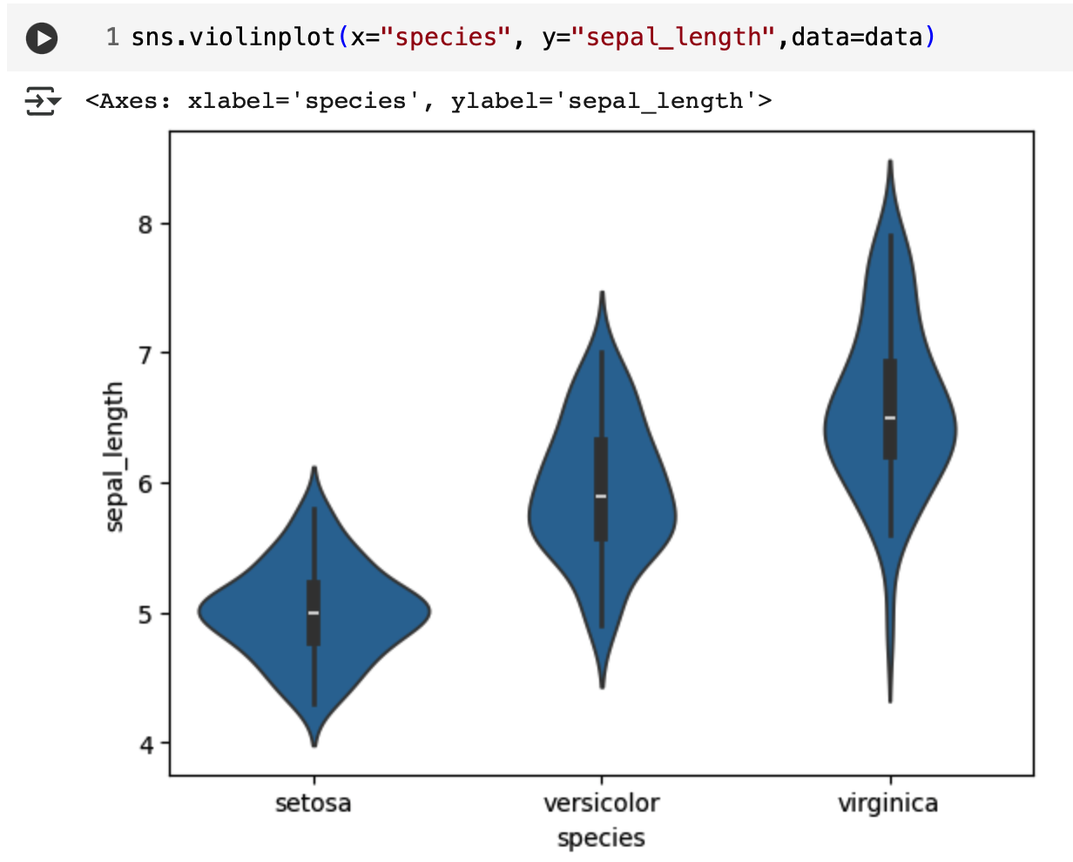

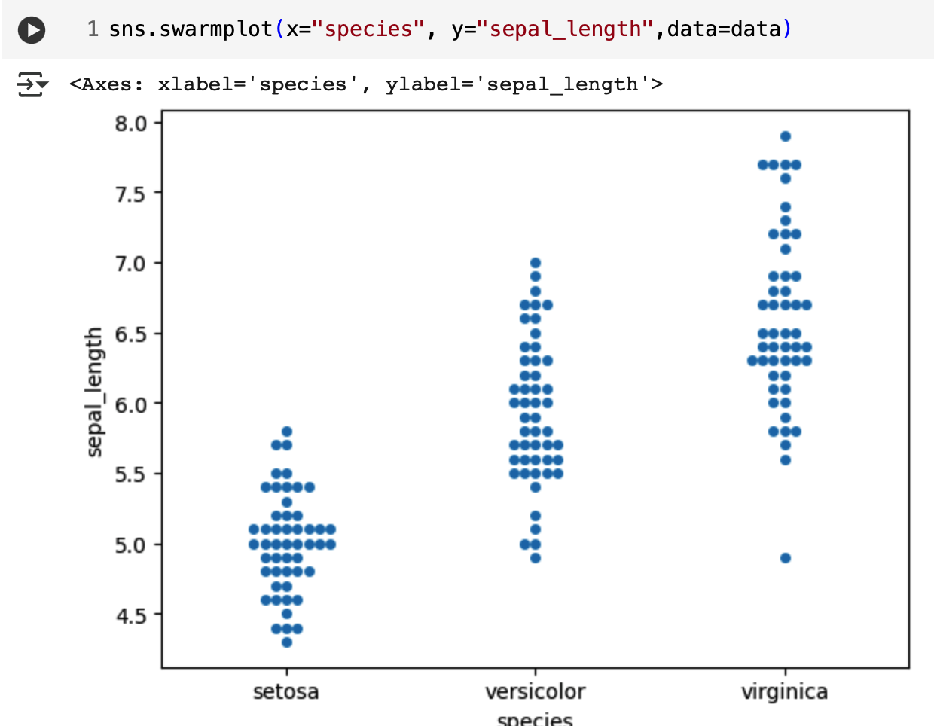

**Automobile Dataset :**

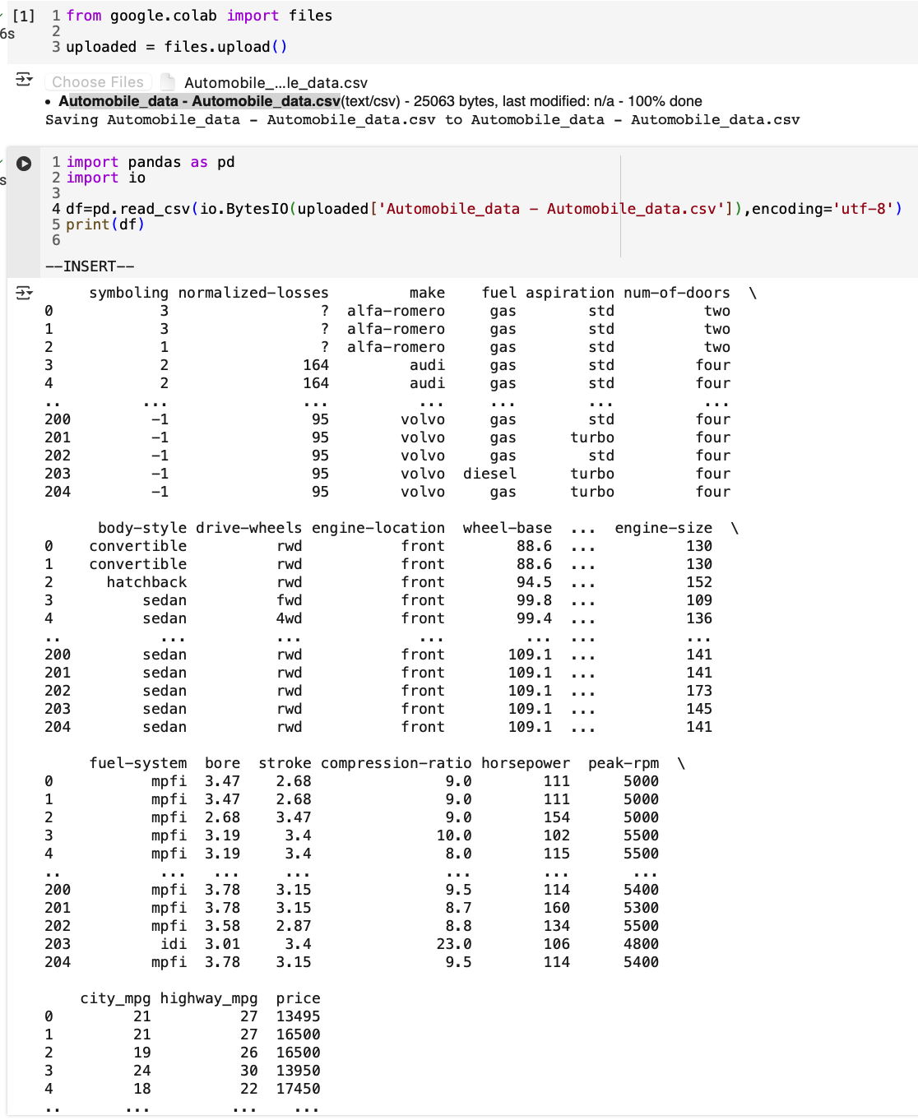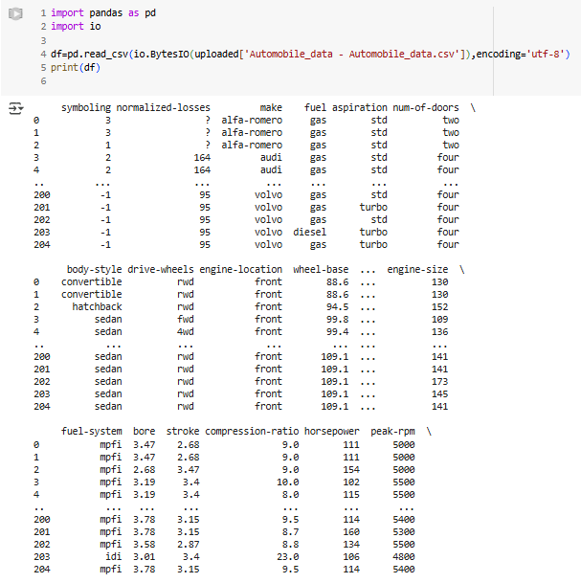

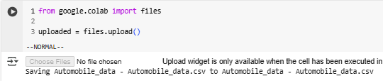

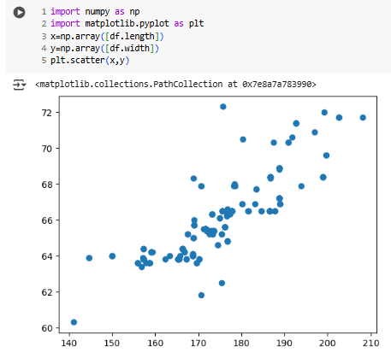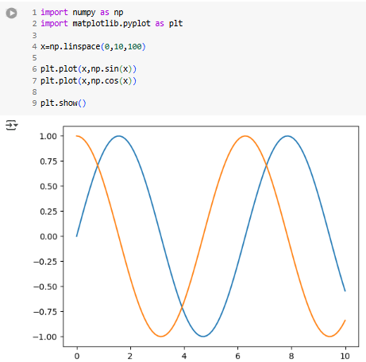

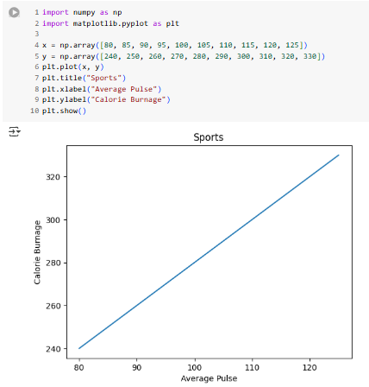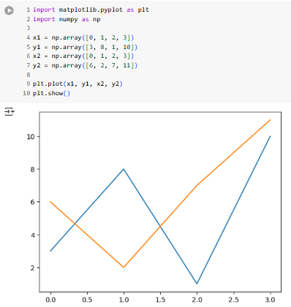

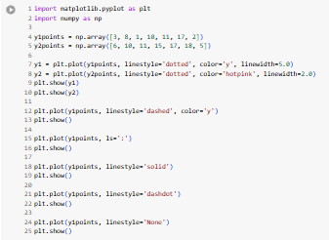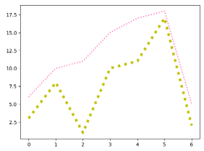

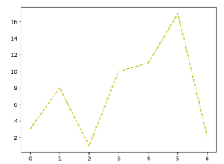 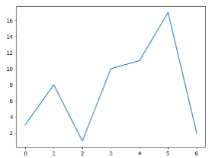

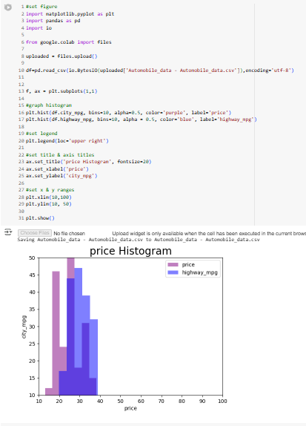

**A. Extended Theory**

1. What is the difference between table and graph?

ANS:

| **GRAPHS** | **CHARTS** |
| --- | --- |
| A graph is a chart that shows the mathematical relationship between varied data sets by plotting horizontal (X-axis) and vertical (Y-axis). | A chart represents information as a diagram, table, or graph. It comprises various methods for presenting large information. |
| All graphs are charts. It means that no matter which type of graph one uses to display the data, it will always be a type of chart subset. | All charts are not graphs. It means there can be other types of charts that are not graphs. |
| Graphs can be used for raw data and visually represent trends and changes in the data. | Ideal for those forms of data which can be easily structured or categorized into small subsets of simple and easily understandable figures. |
| A graph is an ideal choice for those data which depict some trend or relation between variables described on the graph. | We can also use charts in those cases where the data shown does not depict any trend or relationship. |
| Line Graph and bar graph. | Popular chart types are pie charts, histograms, and vertical and historical Bar Chart. |
| Graphs require a numerical dataset with measurable variables. | Charts can include non-numerical data, such as organizational structures or timelines. |